**MOCK UP - FIRST TIME USER FOR SENIOR AND JUNIOR**

**Fig#1. SeniorAdopt app front - First timer registry, applies for both Senior and Junior**

**APP FRONT SIGN UP PAGE**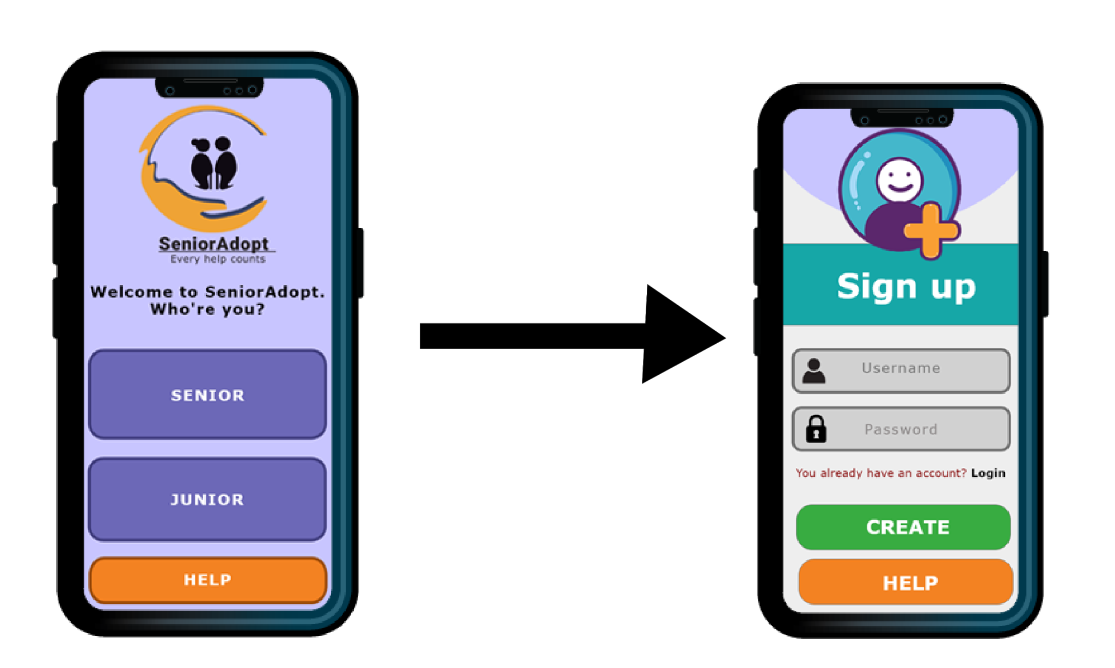

This is the first page of the app once it has been downloaded, installed and launched, it'll be a common page for both Senior and Junior when they haven't had an account before.

The purpose of this page is to determine what kind of role the user is, and to direct into the correct role and position. It's important to choose the one that applies the most and with one-click on the available options, it'll select the chosen role and it'll redirect to a Sign Up page.

**Fig#1.2. Sign Up page - this page applies for Senior and Junior**

Apply for both elderly users and students. Here, they'll need to create their username and password. Username consists of alphabets and can combine with capital letter, numbers, but refrain from the use of space and comma. It's possible to use underscore and hashtag.

The password applies the same way as the username, the user will be able to fabricate their own unique password - to meet the criteria, the password length should contain at least 6-7 characters.

The information is being stored in a database, sensitive information will be protected and encrypted with a secure password.

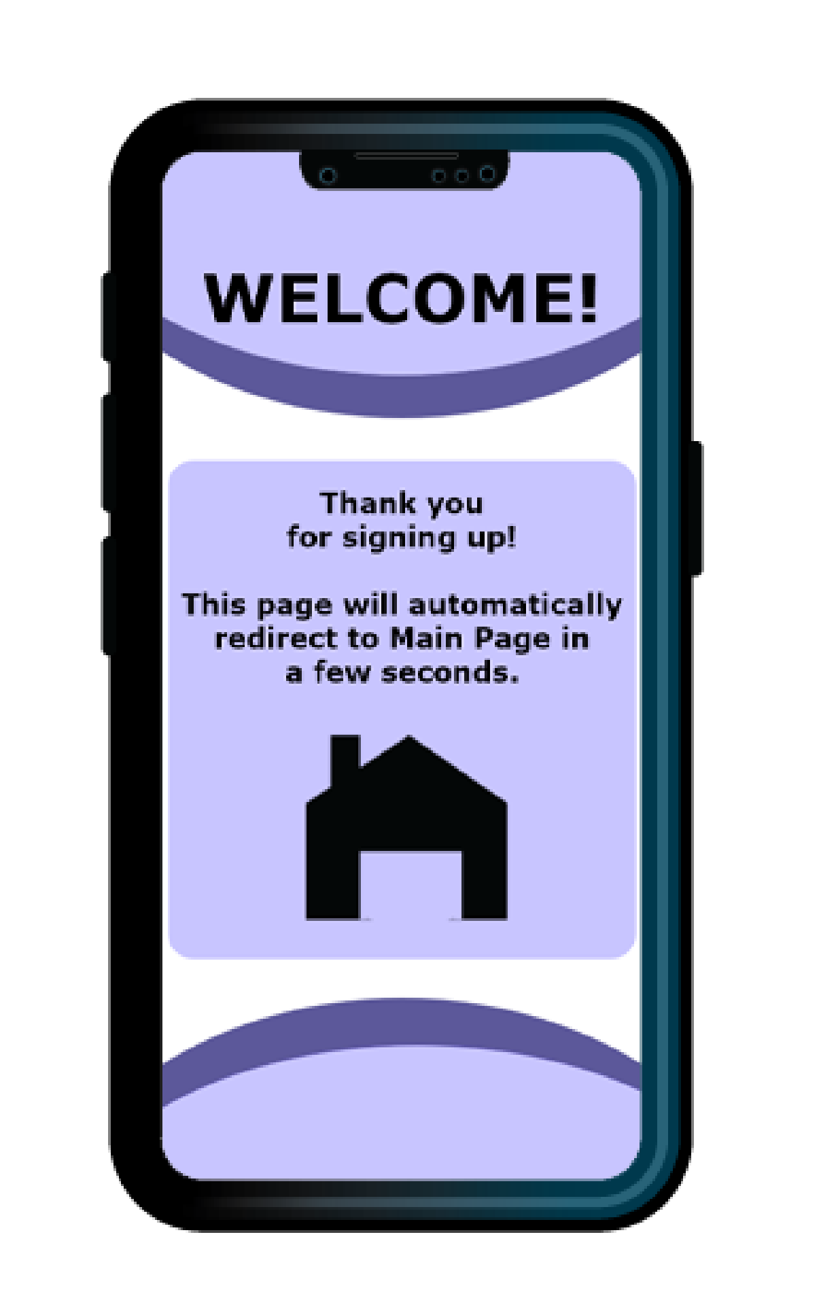

**Fig#1.3. Welcoming Page - this page will appear for Senior and Junior**

When the user has completed the sign up register and clicked on CREATE, the Welcoming Page will redirect the user to the Main Page.

**Fig#2. Main Page - this is what the senior will see once the Welcoming Page has redirected them**

After the whole welcoming and sign up and account has been created, this is what the senior will see. Also, when the app is being relaunched, this is the page the senior will see.

**MOCK UP - ALREADY HAVE AN ACCOUNT: Senior interface**

If a user already has an account, then, this will be the first page the user will see when launching/activating the app. Logging in will redirect the user to the MAIN PAGE.

**Fig#1.1 Already sign up or have an account - START PAGE**.

**Once login has been successfully done, this will take the user to MAIN PAGE.**

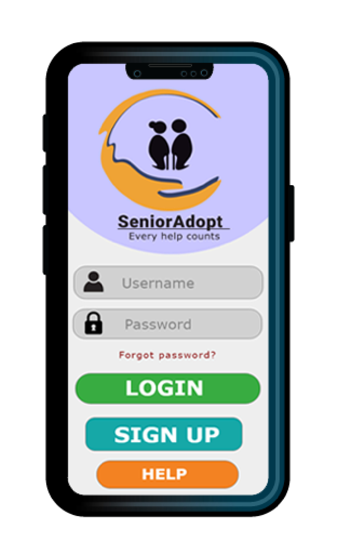  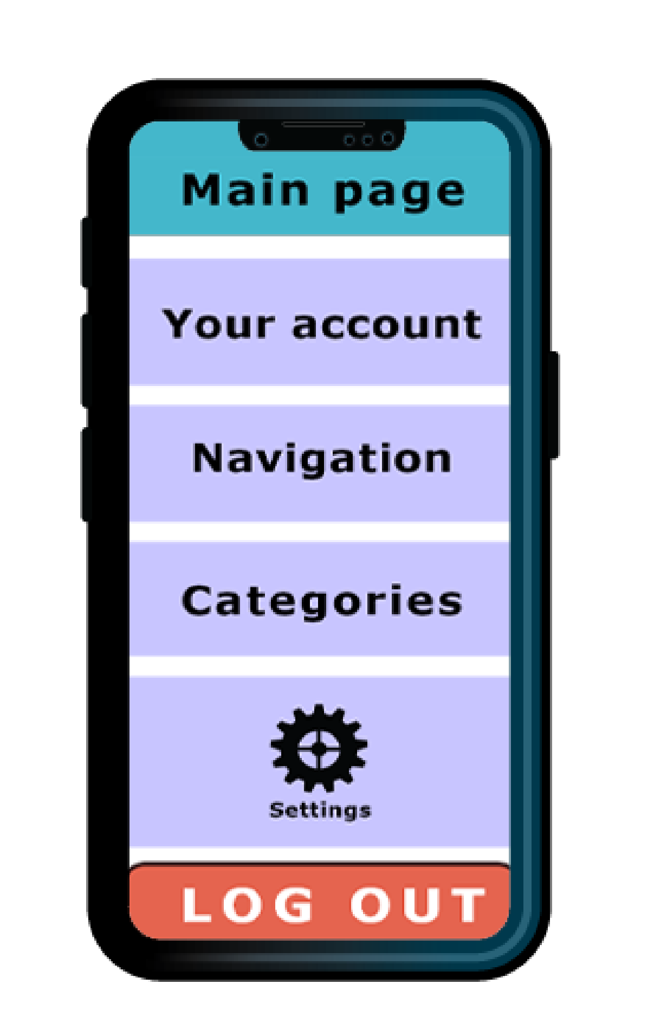

**START PAGE MAIN PAGE**

For the Start Page of the app before logging into the main page. I wanted the layout to contain less distraction as possible considering this interface is suitable for the seniors.

The logo will remain on top and is clickable (and it will take the user to the main page).

The login button features a large font size as well as the Register button has been customized and becomes large enough to see.

I wanted to create a simple clean interface, so this one I believe will be easy for the seniors to use.

**SeniorAdopt: Help page**

For this help page, it’ll go under the HELP option in the front of the start page of the app. I think it’s important to include this as emergency numbers should always be in hand just in case something’s happening whether be accidents or robbery etc.  
I want to give the app a bit of diversion so the app can be used to call for emergency incidents as well.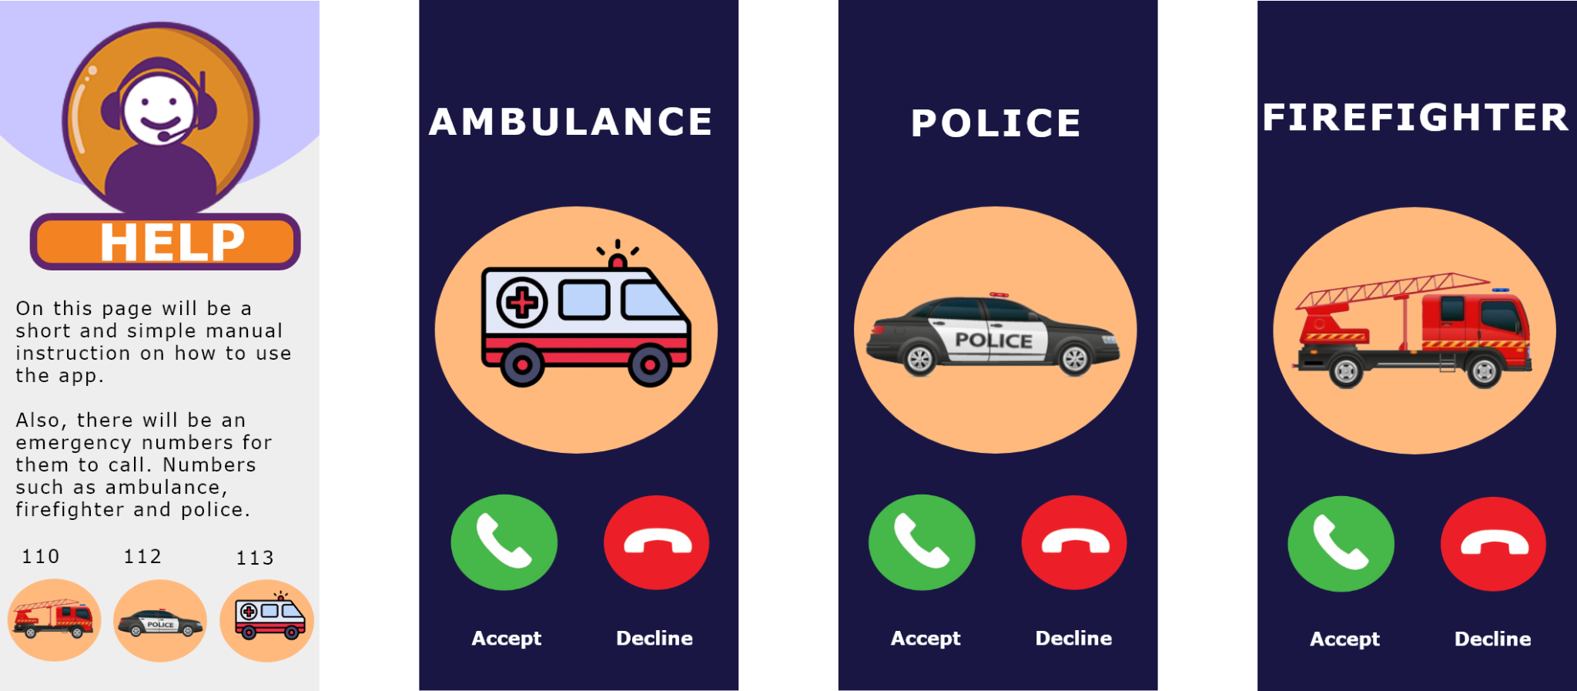

**SA: Senior interface: Navigation and Profile  
  
Navigation:** Option menus for the senior to choose, they can check for the junior candidates’ profiles, check notifications and start booking a junior.   
The notification will let the senior know about how many notifications have they received, as for this example, there are 4 notifications visible (with 2 being new and 2 being old).

**Profile:** This will be a database containing profiles of the junior candidates, here the seniors can read more about the junior candidates, view the credentials, resume, view the recommendation etc.. Providing so much information will help the seniors build trust and learn more about the suitable candidate.

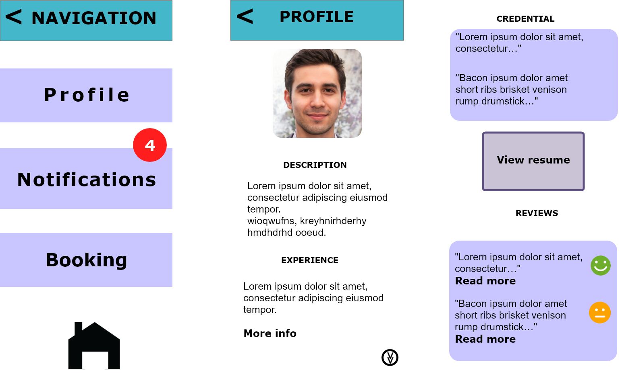

**SA: Senior interface: Notifications and Settings  
  
Notifications:** Has its own page dedicated to the notification alert. Here the senior will be able to view the messages they’ve received, this can be from booking confirmations, messages between the senior and junior.   
The notification alert regarding the update of the app will be appearing only when it’s about time to update the new version - and it will be visible in the Notifications page.   
  
**Settings:** Appears almost similar style as the smartphone options, however, this setting page will appear for both senior and junior, it’s a common setting page which will not be much different from each other. The setting of the app will give the user the option to toggle Dark Mode, change password, edit profile, and be able to turn on and off the notification alert (turning it off will put the notification on mute).  
Language option gives the senior the language preference they wish to use, there is an arrow pointing aside, this indicates there’s more options for the language.  
The Delete my account appears in the red color is to show the danger and if not careful, the account will be completely deleted and also the stored data will be permanently deleted - unless chosen to keep the data stored in the app for future use if the user decides to return.

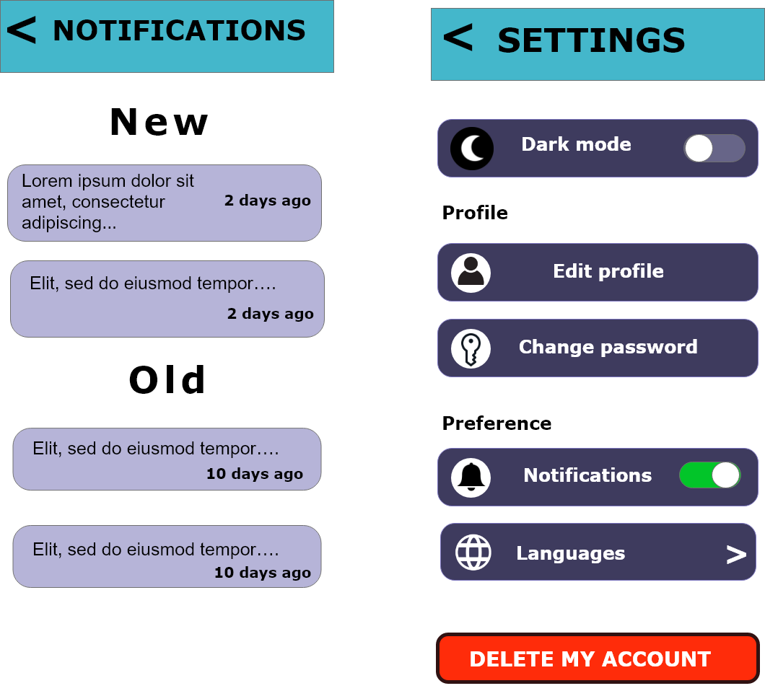

**SA: Senior interface: Categories**

As for the Categories, the seniors will have an opportunity to choose the service they wish to do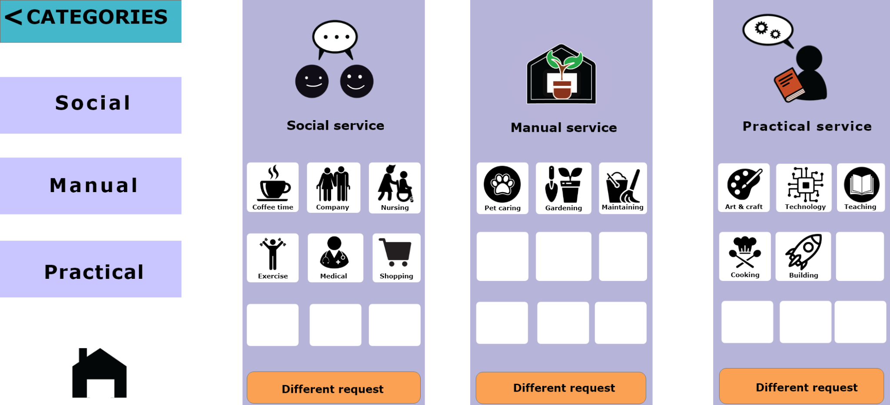

**SA: Senior interface: Booking and Video presentation**

The Booking Page will contain the junior candidates’ databases, the senior can just click on the candidate’s box in order to book the candidate and be able to contact him/her via a video presentation. The video presentation will be a facetime between the senior and the junior. The green border around the video box indicates an ongoing call, there are two icons; one green receiver and red hang-up phone - similar design as the iPhone UI itself, just some inspiration.

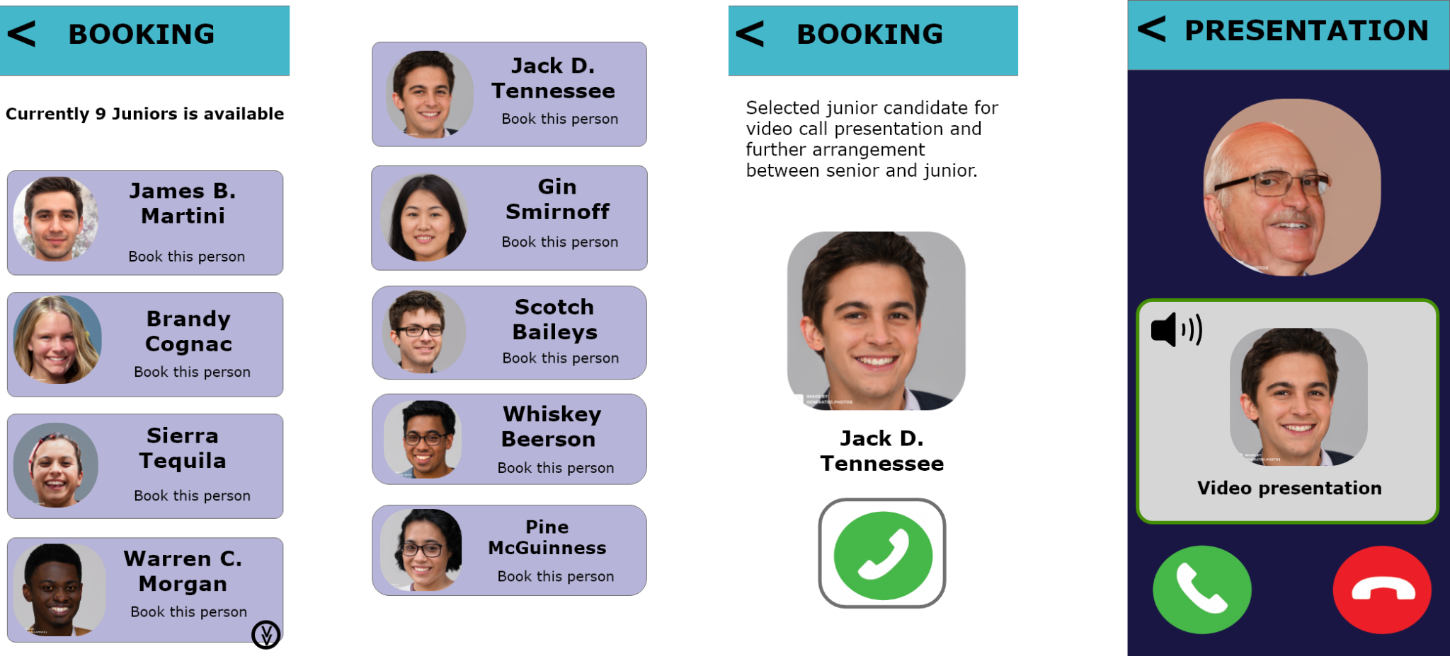

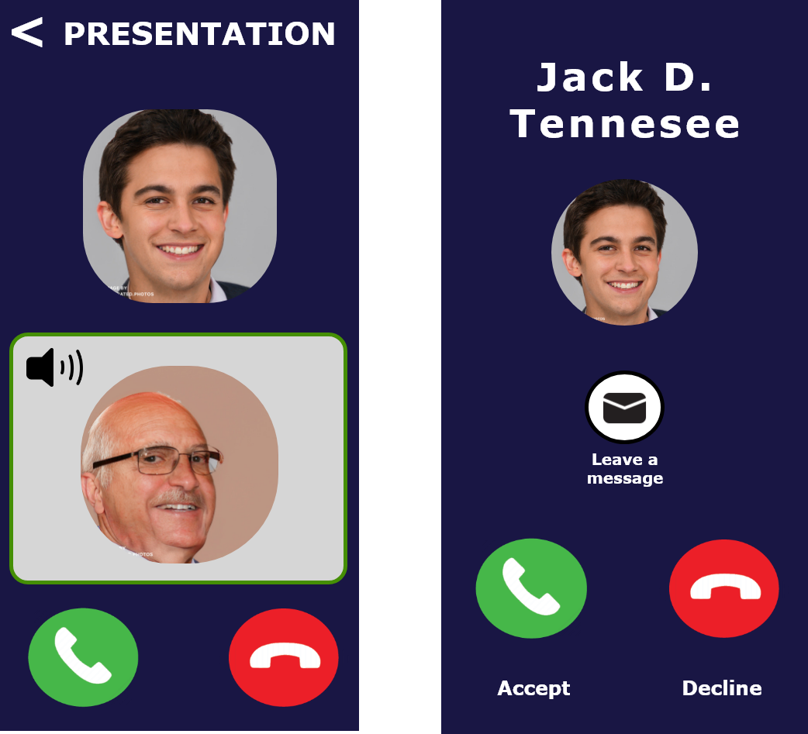

**SA: Senior interface: Edit profile**

This is the account page (or profile) for the senior, here they’ll be able to not only upload and update a new ID photo of themselves, but also edit privacy such as change password, username and email.  
Viewing the past booking history of the junior candidates, update or edit the details, adding some interests just to match with the junior candidate’s skills and passions.  
  
The log out button will just logging off the account and take the senior to the start page of the app

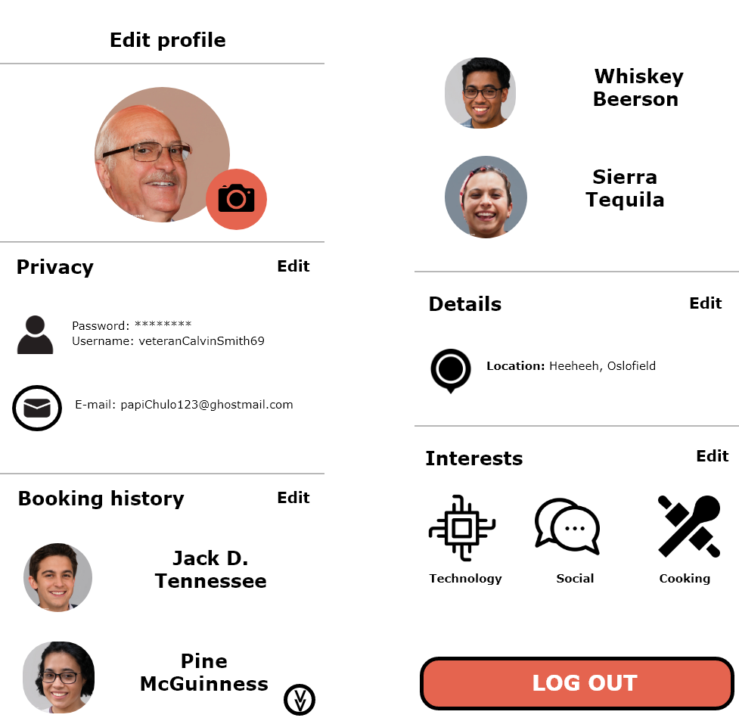

**MOCK UP - FIRST TIME USER: Junior interface**

This is the Junior’s start page, slightly different from the Senior’s. The only thing that’s different is the login button and the color itself, and also, there is no emergency help button. The design is merely different either, just at the bottom there’s a small decor just for the design.   
The first time entering the app, this is what the first timer page will look like, it applies both to senior and junior. So, basically, this will be the page they will see only once and won’t be seeing it again after the sign up has been completed.

**APP FRONT SIGN UP PAGE**

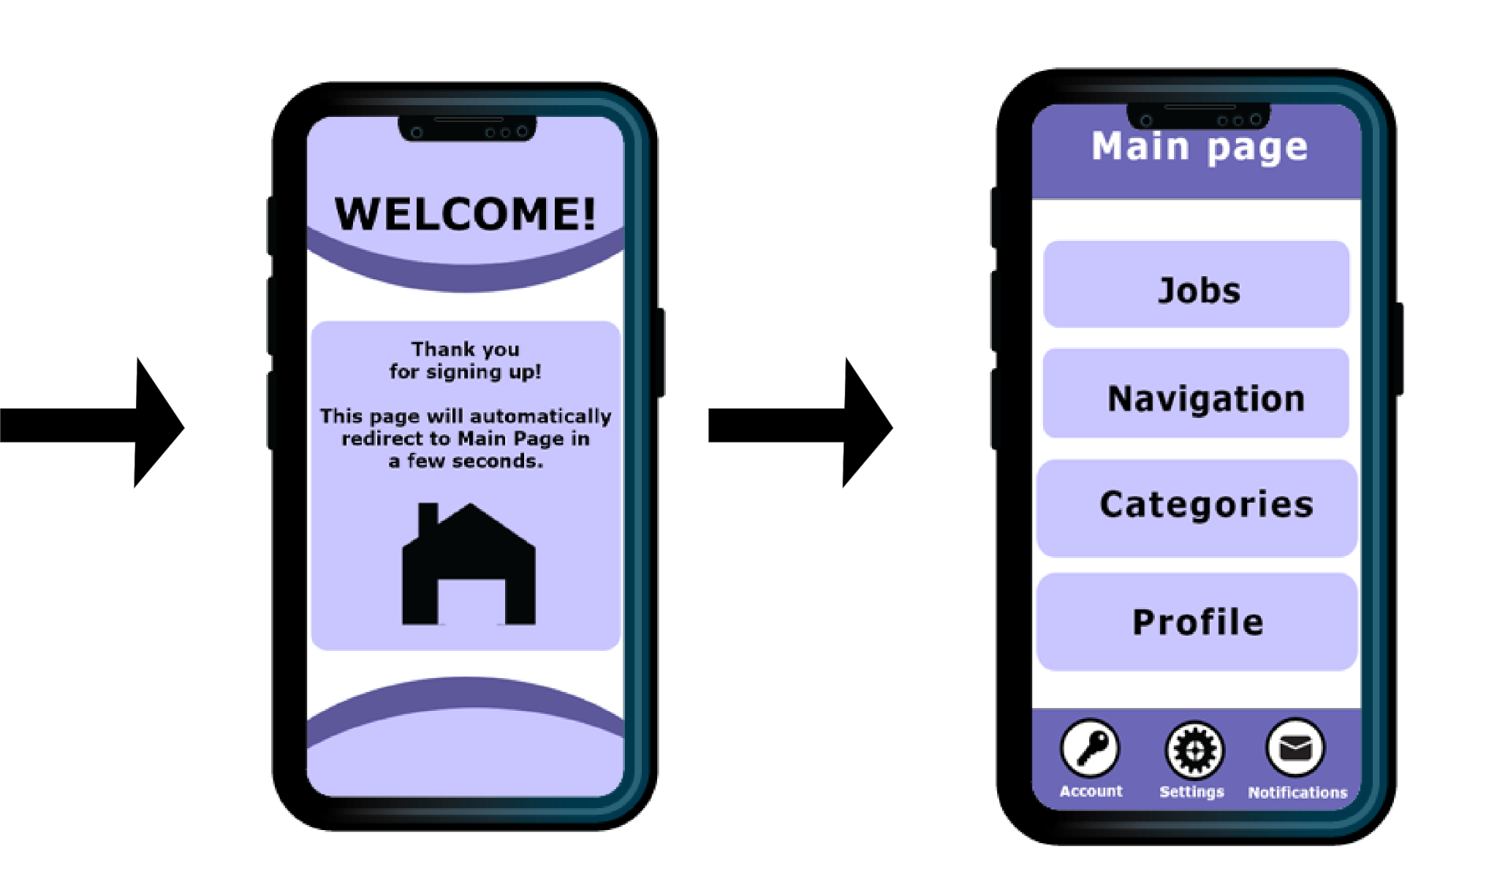

The Main Page for the junior may have a slightly smaller change, there is now “Jobs” option visible, the design layout is also much different from the senior interface design. The junior now has Settings, Account and Notifications as a menu option visible at the bottom (this will remain at the bottom of the interface).

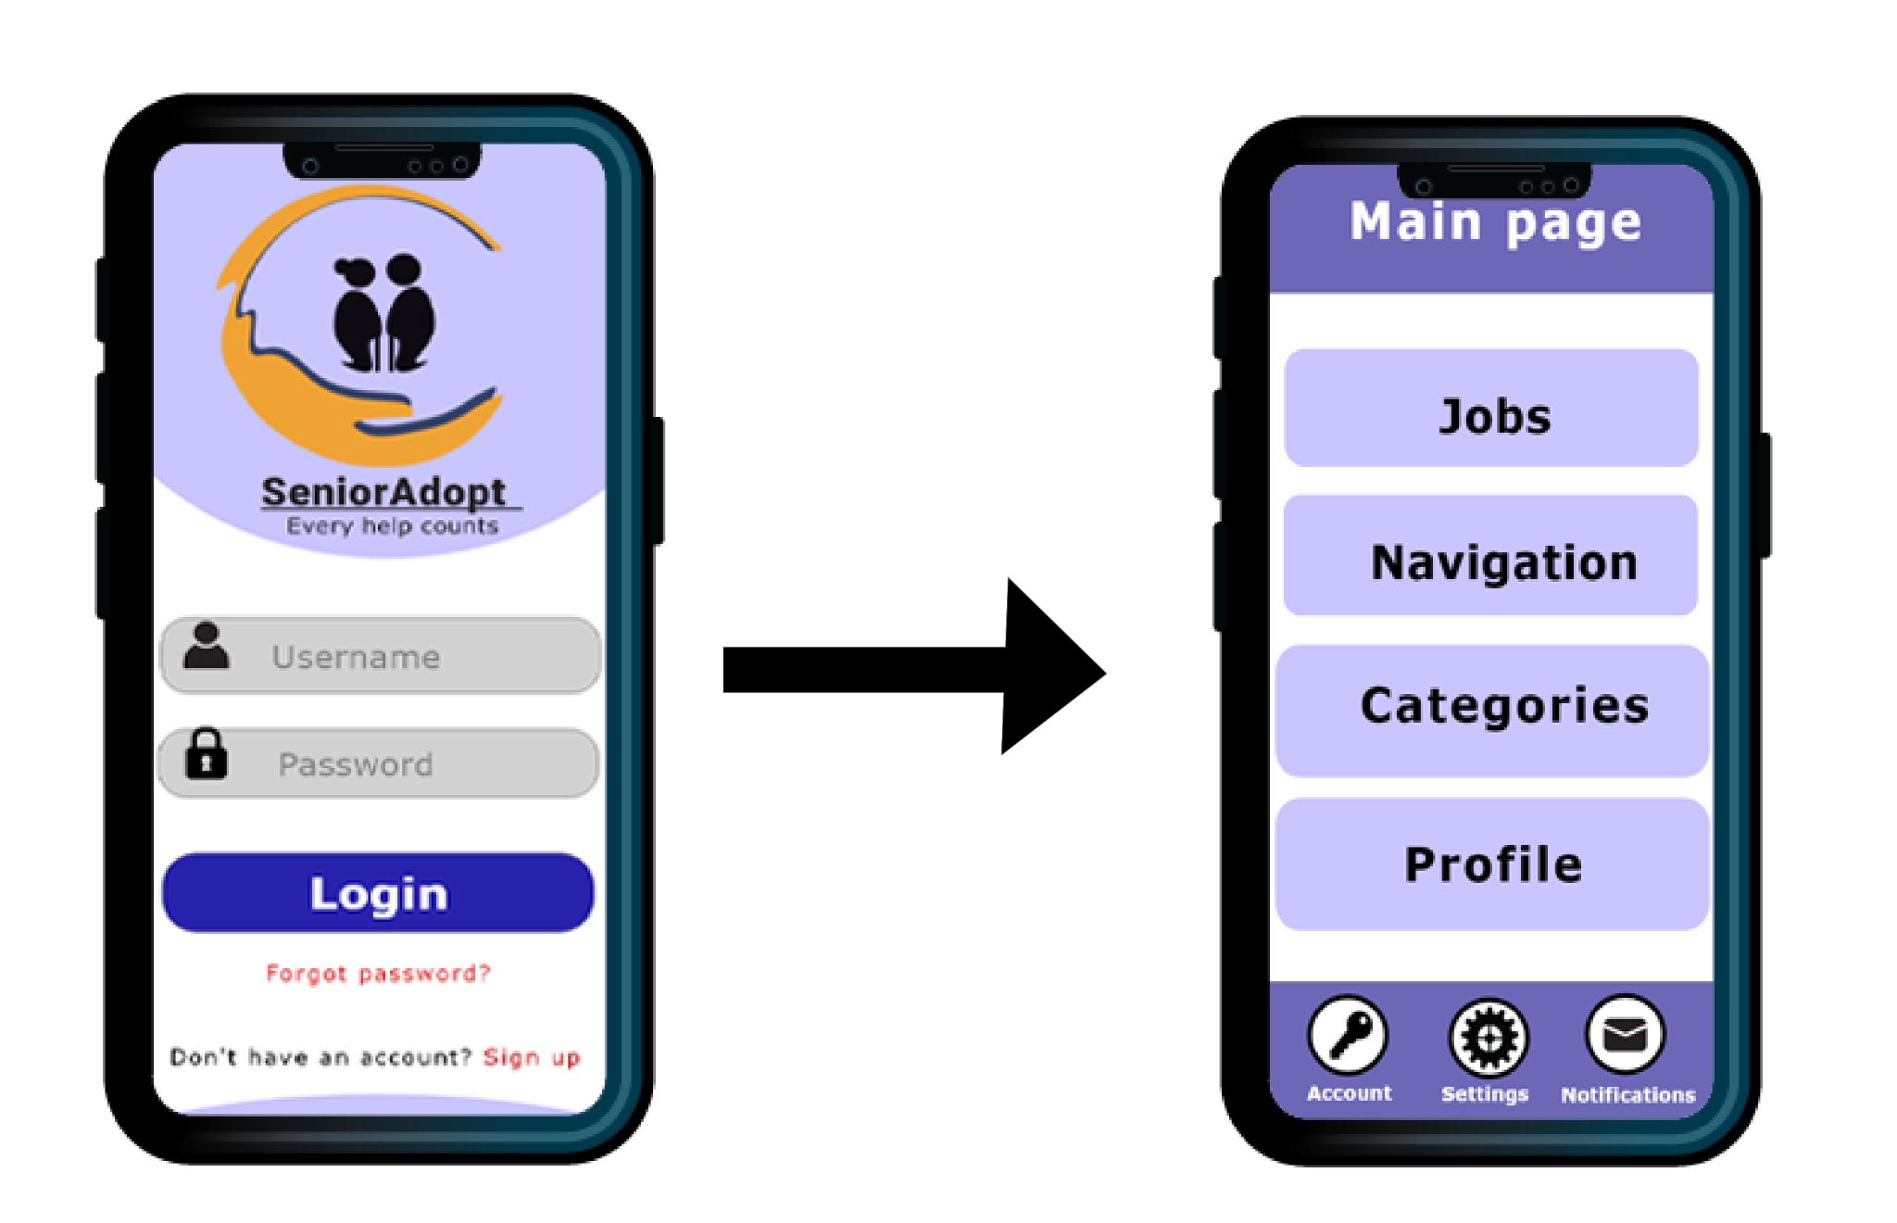

**MOCK UP - ALREADY HAVE AN ACCOUNT: Senior interface**

* NOTES:
* **Fig#1:** Once the app is downloaded and installed.   
  This is what the first-time user will see. He/she will be able to choose which role he/she fits into.  
  The app Front Page and Sign-up page is shared the same for Senior and Junior user.  
  If chosen Senior, then it will lead the user to the Sign-Up page.
* **Fig#1.2:** Sign-Up Page will only need to be filled once. When the sign up has been successful and the account has been created.   
  The page will lead to Welcoming Page.
* **Fig#1.3:** Welcoming Page shows that the sign up has been successful. The user can now proceed to the Main Page.
* **Fig#2:** Start Page common for both Senior and Junior. This is the page user will be seeing when they are logging in after logging out.  
  User (Senior or Junior) will be required to enter username and password.  
  The Sign-Up option on this page will lead to account creation page (Sign-Up page).
* **Fig#2.1:** Main Page for Senior consists of simple minimalistic option menus. We wanted to create a simple option with one-click emphasizes on the touch screen.   
  The log out button will remain at the bottom; the color will be color that represents alert and warning.

**Navigation**

* Services show as an icon and should be easy to maneuver around.

**Profile**

* The concept of this page is to give the Senior user an in-depth of the specific Junior candidate.  
  Senior will get to read Junior candidate's description about him/herself, reviews, view resume, credentials and experience.
* D
* D
* D
* Clicking on the Categories will take user to this page. The Categories page provide the Senior with the offers they can choose from.
* Services show as an icon and should be easy to maneuver around.

**Social service**

* is about social interaction. A social gathering whether it's group exercise, coffee time (social group with other elderly for game activities), company (having someone to talk to).

**Manual service**

* is about the Junior interaction with Senior by providing the service
* D

**Practical service**

* Focuses on providing teaching, knowledge and Junior user uses their skills to teach the Senior.
* Ssss
* Account Page for Senior. The basic of what a profile supposes to be.   
  The Senior can update or change password, username and their email.
* This page can be scrolled down.
* Booking history for Senior indicates the history of the Junior a Senior user has booked in the past.
* Details is for location of where Senior user is at. It'll make finding Junior much more efficiently.
* Interests for Senior user is for matching up with the Junior user's skills and experience.
* Log out button will be available if the Senior decides to log out via Account page.

**Notifications**

* Contain messages from old and new.  
  It can be scrolled down if there is a lot of messages, there will be a downward arrow (it will appear automatically if there's a lot of messages).
* There will be an indication on date or how many hours ago the message has been received on inbox.
* Interface for this page will remain clean with white background, with borders use as background for those texts.

**Settings**

* provide availability on toggle dark mode, edit profile, change password (although, Senior and Junior user can edit this on Account).
* Notification's alert can be toggle off and on. Having it off, will have notification become mute, every message receives will be sent directly to the inbox.